

Notes from the Edge
  - Insights into an Evolving Future
VOL 7 – ISSUE 9 | September 2017
A Product of the Futures Assessment Division
Table of Contents
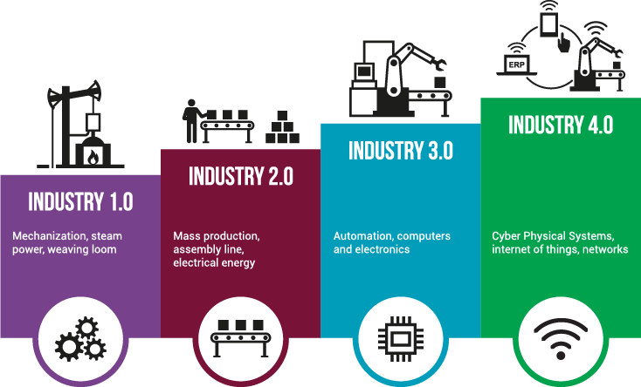
Future of Logisitics 1
Artificial Intelligence 2
Medical Technology 3
Cyber Attacks 3
Futures Assessment Division 3

Future of Logisitics
What does Industry 4.0 mean for the future of logistics? Rapid advances in artificial intelligence will change the way we manage logistics across a range of industries. The logistics industry hasn’t traditionally been at the forefront of IT innovation, despite the fact that as a sector, it has huge potential for benefiting from the application of advanced technology. Industry 4.0 will affect all of us: the way that we live our lives, communicate and interact with each other, as well as how we make and move things. The author discusses the topics of:
1. Industry 4.0 in the supply chain
2. Using data to optimize transport
3. A timescale for change
4. The drivers of change
5. Brexit as a catalyst for change.
Industry 4.0

Three trends manufacturing CEOs MUST know about. Three trending developments are rarely discussed but will have an enormous effect on U.S. manufacturers in the coming decade: 1) The ongoing shift from a labor rich to a labor scarce global economy; 2) Urbanization will reshape supply chains and accelerate labor productivity growth; and 3) Africa’s promise: favorable demographics and accelerating economic growth shed light on an economically challenging continent. Global labor scarcities and population concentrations will provoke a rethinking on production and supply chains. The best bet is to invest in technology because it will only grow in importance, leverage the production potential of growing urban areas, and identify the regions of Africa that have ideal conditions for profitable investment. Are You In the Know?

What does Industry 4.0 look like in China? China’s Tianjin Economic-Technological Development Area (TEDA) is a prime example of the country’s Made in China 2025 strategy. The area has a GDP of $45 billion USD and a growth rate of over 10 percent. Moreover, its proximity to the Tianjin Port means that it stands to benefit considerably from China’s Belt and Road Initiative, which will invest $900 billion to foster connectivity between China and Western Europe, with access to trade centers in all major regions in between. The author discusses the synergy of TEDA’s upgraded autonomous infrastructure combined with the areas access to critical high speed logistics nodes. Silk Road 2.0

Why robots will improve manufacturing jobs. People have feared the march of the machine for centuries. Yet for just as long, machines have changed work; they have not replaced it. And the emerging fourth industrial revolution — even with its digital, automated assembly lines — is not an exception to this trend. As this new way of doing business becomes a reality, humans and machines will each play a critical role in manufacturing’s success. AI and Robotics Change Work

Artificial Intelligence
'Brain-like' supercomputers could enable better defense decision-making. The TrueNorth neuromorphic microchip is designed to emulate the human brain and its remarkable efficiency. The TrueNorth chip contains a million "neurons" that transmit data back and forth in a way similar to human brain neurons by using patterns of pulses similar to the way human neurons use electrochemical pulses. TrueNorth's heightened capabilities could help human defense analysts comb through data and spot vital information more quickly, which in turn, could enable military planners at all levels to make better-informed decisions in less time. Silicon Brains

10 ways AI will affect our lives in 2050, according to leading scientist. Dr. Toby Walsh, a leading Australian artificial intelligence (AI) scientist, recently warned about the future that AI will produce. He’s issued a call for discussion about the implementation of guidelines that could limit AI’s influence. In his book, It’s Alive!: Artificial Intelligence from the Logic Piano to Killer Robots, Dr. Walsh tells us how he believes the world could change in the next 30 years. See the linked article for a summary of his list of 10 Ways AI Will Affect Our Lives in 2050. AI in 2050

Putin says whoever has the best artificial intelligence will rule the world. For some time now there has been a steadily growing debate over the potential benefits and hazards of AI drawing opinions from technology pioneers, futurists, scientists, philosophers, and most recently Russian President Vladimir Putin. Especially when it comes to the military, the core issues have become almost as much existential as technical, with some suggesting that a future with “killer robots” could be one without humans. On Knowledge Day, Sept. 1, 2017, the Russian leader stated, “Artificial intelligence is the future, not only for Russia, but for all humankind,” He explained. “It comes with colossal opportunities, but also threats that are difficult to predict. Whoever becomes the leader in this sphere will become the ruler of the world.” Russia Seeks World Lead in AI

What AI-enhanced health care could look like in 5 years. In her 2017 Internet Trends report, Mary Meeker singled out healthcare as a sector ripe with opportunity. She proposed that the healthcare market, driven by a number of converging technologies, is approaching a “digital inflection point” and is currently positioned for rapid growth. The author believes that the healthcare sector has the potential to undergo a complete metamorphosis courtesy of breakthrough AI technologies such as:
1. Physicians will practice with AI virtual assistants.
2. Physicians with AI virtual assistants will be able to treat 5X – 10X as many patients.
3. AI virtual assistants will support health maintenance with ongoing and real-time intelligent advice.
4. Medical devices previously only available in hospitals will be available in the home.
5. Affordable new tools for diagnosis and treatment of illnesses will emerge based on data collected from extant and widely adopted digital devices such as smartphones.
6. Robotics and in-home AI systems will assist patients with independent living.
Medical Manned-Unmanned Teaming

Medical Technology
New gene editing tech promises to be even better than CRISPR. Just when we were getting used to the CRISPR/Cas9 gene editing revolution, a new “fourth-generation” DNA base editor has come along — offering a new way to modify the genetic code that may be safer in terms of reducing potential mistakes. “Cutting-based strategies have their own strengths, but one challenge facing cutting-based approaches is that making double-stranded breaks in genomic DNA tends to result in a stochastic mixture of products containing insertions, deletions, and translocations at the cut site.” The fourth-generation approach, called base editing, is a relatively new approach to genome editing and offers a way to improve base editing efficiencies, while greatly reducing undesired byproducts — thereby making the edits much “cleaner.” The Future of PGMs… Precision Gene Modification

Five ways to get CRISPR into the body. The gene-editing technology CRISPR has the potential to treat—and possibly cure—any number of diseases. But in order for the DNA editing to happen inside you, CRISPR needs to find its way to the right part of the body. That mostly means getting a DNA-cutting protein called Cas9, normally found in bacteria, to work in your cells. To do that, researchers are trying out some surprising delivery techniques. In her article, Emily Mullin describes application techniques such as:
1. Gels and creams
2. Drinkable or edible CRISPR
3. Ear injections
4. Skin grafts
5. “Ex vivo” therapy.
Gene Editing Gels

Cyber Attacks
Scientists hack a computer using DNA. In what appears to be the first successful hack of a software program using DNA, researchers say malware they incorporated into a genetic molecule allowed them to take control of a computer used to analyze it. The biological malware was created by scientists at the University of Washington in Seattle, who call it the first “DNA-based exploit of a computer system.” The researchers warn that hackers could one day use faked blood or spit samples to gain access to university computers, steal information from police forensics labs, or infect genome files shared by scientists. DNA Encoded Malware

How a fish tank helped hack a casino. Hackers are constantly looking for new ways to access data. Hackers attempted to acquire data from a North American casino by using an Internet-connected fish tank, according to a report released Thursday by cybersecurity firm Darktrace. Justin Fier, Dark traces director of cyber intelligence said, “Somebody got into the fish tank and used it to move around into other areas [of the network] and sent out [10 GB of data were sent out to a device in Finland].” Fishy Heist


Futures Assessment Division

The Science Fiction Futures anthology, the MCSEF, and previous editions of Notes from the Edge can be found at the link:
Futures Assessment Division

“Let us not go over the old ground, let us rather prepare for what is to come.” – Marcus Tullius Cicero
This newsletter is intended to highlight issues and ideas which may prove significant in the evolving future. In keeping with our focus on both alternative futures and analysis, items in this bulletin will generally be of an alternative nature, or drawn from atypical sources.

